Assignment 3

Write programs to implement (i) Spectral bisection algorithm (based on second smallest eigen value of L) and (ii) Modularity maximization algorithm (based on largest eigen value of B). Compare the communities obtained as well as the the time taken by the two algorithms by running your program on the bench mark data set Karate club (available in SNAP). Tabulate your results by giving Precision, Recall and F-Measure for the two algorithms along with the time taken by the algorithm.

Project report :

- Implementation :
  - For community detection;
    - we have taken the modularity matrix representation of the graph.
    - calculated the eigenvector corresponding to the largest eigen value.
    - partitioned vertices according to the signs of the vector elements.

  - For graph partitioning;
    - We started with the Laplacian matrix representation of the graph
    - calculate the eigen vector v2 corresponding to the 2nd smallest eigen value.
    - Sort the elements of the eigenvector.
    - In order to divide the network into partition containing n1 & n2 nodes,
      - put 1st n1 nodes into one partition and rest n2 nodes into another and calculate the size of the cut set.
      - again put last n1 nodes into one partition and rest n2 nodes into another and calculate the size of the cut set.
    - Choose that division which has smaller cut size.

- Comparison :
  - Before comparing these two techniques we must note that --
    - One algorithm is for partitioning the graph for which we had to provide the number of partitions or communities and there respective sizes.
    - Whereas another is for community detection where no such prior information was given.
  - Here is the true community partition for the Zachary karate club, against which we will calculate Precision, Recall and F-Measure of our implementation.
Community 1 : {1, 2, 3, 4, 5, 6, 7, 8, 11, 12, 13, 14, 17, 18, 20, 22}
Community 2 : {32, 33, 34, 9, 10, 15, 16, 19, 21, 23, 24, 25, 26, 27, 28, 29, 30, 31}
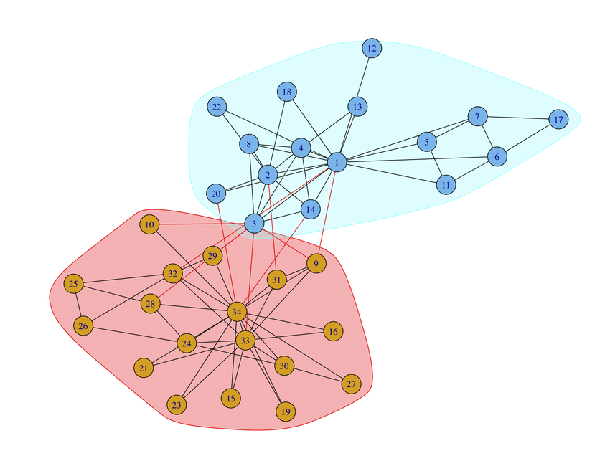

True communities of Zacharys karate club network

  - Output for spectral partitioning……

......Own implementation.......
Community 1 : {1, 2, 3, 4, 5, 6, 7, 8, 11, 12, 13, 14, 15, 16, 17, 18}
Community 2 : {32, 33, 34, 9, 10, 19, 20, 21, 22, 23, 24, 25, 26, 27, 28, 29, 30, 31}
Size : 16 and 18 respectively

......using library function....
Community 1 : {1, 2, 3, 4, 5, 6, 7, 8, 11, 12, 13, 14, 15, 16, 17, 18}
Community 2 : {32, 33, 34, 9, 10, 19, 20, 21, 22, 23, 24, 25, 26, 27, 28, 29, 30, 31}
Size : 16 and 18 respectively

  - Output for Modularity maximization

Community 1 : {1, 2, 3, 4, 34, 6, 7, 15, 20, 21, 28}
Community 2 : {5, 8, 9, 10, 11, 12, 13, 14, 16, 17, 18, 19, 22, 23, 24, 25, 26, 27, 29, 30, 31, 32, 33}
Size : 11 23 respectively

The measurement parameters are defined as,

where,
P : Precision, R : Recall, F1 : F measure
TP : True positive, TN : True negative, FP : False positive, FN : False negative

Spectral partitioning(my implementation) :
TP : {32, 33, 34, 9, 10, 19, 21, 23, 24, 25, 26, 27, 28, 29, 30, 31}
FP : {20, 22}
FN : {16, 15}
Modularity maximization :
TP : {32, 33, 9, 10, 16, 19, 23, 24, 25, 26, 27, 29, 30, 31}
FP : {5, 8, 11, 12, 13, 14, 17, 18, 22}
FN : {34, 28, 21, 15}
Spectral partitioning(using lib function) :
TP : {32, 33, 34, 9, 10, 19, 21, 23, 24, 25, 26, 27, 28, 29, 30, 31}
FP : {20, 22}
FN: {16, 15}

 | Precision (P) | Recall (R) | F-Measure (F)
Spectral bisection  (my implementation) |  |  | 0.889
Modularity  maximisation |  |  | 0.683
Spectral bisection  (using library function) |  |  | 0.889

- Resources :
- Networks – An introduction M.E.J Newman
- https://en.wikipedia.org/wiki/Precision_and_recall

